Template for EBS2019 abstract

J. Doe¹, F. Smith²

1) Istituto di Fisica Applicata Nello Carrara, Via Madonna del Piano 10, 50019 Sesto Fiorentino, Italy
2) Institute for Electromagnetic Sensing of the Environment, CNR, Via Diocleziano 328, 80124 Napoli, Italy
e‐mail: smith@irea.cnr.it

Authors are kindly asked to use ONLY the following MS Word template to submit a one-page abstract in a single-column format. The maximum length of the abstract is one-page following strictly this template (fonts, spacing, etc). Ensure that figures have a sufficient resolution. The maximum figure legend length is 40 words. The maximum file size is 5MB.
Authors are kindly asked to use ONLY the following MS Word template to submit a one-page abstract in a single-column format. The maximum length of the abstract is one-page following strictly this template (fonts, spacing, etc). Ensure that figures have a sufficient resolution. The maximum figure legend length is 40 words. The maximum file size is 5MB.
Authors are kindly asked to use ONLY the following MS Word template to submit a one-page abstract in a single-column format. The maximum length of the abstract is one-page following strictly this template (fonts, spacing, etc). Ensure that figures have a sufficient resolution. The maximum figure legend length is 40 words. The maximum file size is 5MB.
Authors are kindly asked to use ONLY the following MS Word template to submit a one-page abstract in a single-column format. The maximum length of the abstract is one-page following strictly this template (fonts, spacing, etc). Ensure that figures have a sufficient resolution. The maximum figure legend length is 40 words. The maximum file size is 5MB.
Authors are kindly asked to use ONLY the following MS Word template to submit a one-page abstract in a single-column format. The maximum length of the abstract is one-page following strictly this template (fonts, spacing, etc). Ensure that figures have a sufficient resolution. The maximum figure legend length is 40 words. The maximum file size is 5MB.
Authors are kindly asked to use ONLY the following MS Word template to submit a one-page abstract in a single-column format. The maximum length of the abstract is one-page following strictly this template (fonts, spacing, etc). Ensure that figures have a sufficient resolution. The maximum figure legend length is 40 words. The maximum file size is 5MB.

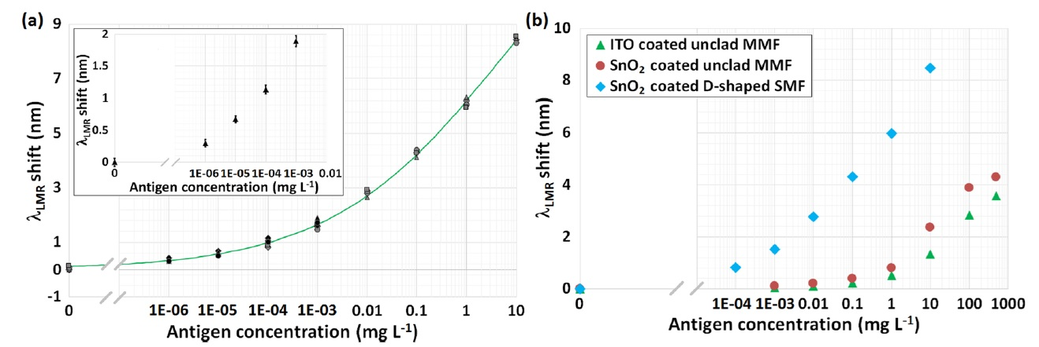

Figure 1. a) Calibration curve of the SnO2-coated D-shaped SMF biosensor. (b) Comparison of the calibration curves obtained with all three kinds of LMR sensors

References:
[1] Y. Sun, X. Fan, Anal. Bioanal. Chem., 399, 205-211 (2011).
[2] .
[3]

